A MINOR PROJECT

**On**

**“Criminal Face Recognition”**

**Submitted for the partial fulfilment for**

**the award of the Degree of**

**Master of Computer Application**



**SUBMITTED TO: SUBMITTED BY:**

**Mr. Shekhar Chander Ashish Swami**

(Assistant Professor) (20MCLN009)

Department Of IT & CA **Prashant Yadav**

(20MCIN007)

**Department of Information Technology & Computer Application**

**JECRC UNIVERSITY, JAIPUR**

**Session: 2020-2021**

**DECLARATION**

We hereby declare that this project work entitled “*Criminal Face Recognition*” has been prepared by us during the year 2020 – 21 under the guidance of Mr. Shekhar Chander, Department of IT & Computer Science, JECRC University in the partial fulfilment of MCA degree prescribed by the University.

We also declare that this project is the outcome of our own effort, that it has not been submitted to any other university for the award of any degree.

**Name of Team Members:**

* **Ashish Swami**

**(20MCLN009)**

* **Prashant Yadav**

**(20MCIN007)**

**ACKNOWLEDGEMENT**

We have taken efforts in this project. However, it would not have been possible without the kind support and help of many individuals and organizations. I would like to extend my sincere thanks to all of them.

We are highly indebted to **Mr. Shekhar Chander**, Department of IT & Computer Science, JECRC University for his guidance and constant supervision as well as for providing necessary information regarding the project & also for their support in completing the project.

I would like to express my gratitude towards my parents & member of **JECRC University** for their kind co-operation and encouragement which help me in completion of this project.

My thanks and appreciations also go to my friends in developing the project and people who have willingly helped me out with their abilities.

**TABLE OF CONTENTS**

1. **Abstract**
2. **Introduction**
3. **Feasibility study**
4. **System requirement analysis**
5. **Literature survey**
6. **System design**
7. **Face Recognition**
   1. **Techniques of Face Recognition**
   2. **How Face Recognition Works?**
   3. **Current Research on Face Recognition And Techniques Available**
8. **Introduction To Basic Terms Used in Project**
   1. **Python**
   2. **Tkinter**
9. **OpenCv**
10. **Classifier Cascades**
    1. **Haar Cascade**
11. **Local Binary Pattern Histogram(LBPH)**
12. **Coding**
13. **Testing**
14. **Implementaion**
15. **Snapshots**
16. **Conclusion**
17. **Bibliography**

**1.ABSTRACT**

Face recognition is one of the most challenging topics in computer vision today. It has applications ranging from security and surveillance to entertainment websites. Face recognition software are useful in banks, airports, and other institutions for screening customers. Germany and Australia have deployed face recognition at borders and customs for Automatic Passport Control.

Human face is a dynamic object having high degree of variability in its appearance which makes face recognition a difficult problem in computer vision. In this field, accuracy and speed of identification is a main issue.

Many challenges exist for face recognition. The robustness of the system can be obstructed by humans who alter their facial features through wearing coloured contact lenses, growing a moustache, putting on intense make-up, etc. Ethical concerns are also related to the process of recording, studying, and recognizing faces. Many individuals do not approve of surveillance systems which take numerous photographs of people who have not authorized this action.

The goal of this paper is to evaluate face detection and recognition techniques and provide a complete solution for image based face detection and recognition with higher accuracy, better response rate and an initial step for video surveillance. Solution is proposed based on performed tests on various face rich databases in terms of subjects, pose, emotions and light.

**2.INTRODUCTION**

Criminal record contains personal information about a particular person along with photograph. To identify any criminal we need identification regarding that person, which are given by the eyewitness. Identification can be done by finger print, eyes, DNA etc. The face is our primary focus of attention in social intercourse playing a major role in conveying identity and emotion. Although it is difficult to infer intelligence or character from facial appearance, the human ability to remember and recognize faces is remarkable.

A face recognition system uses a database of images and compares another image against those to find a match, if one exists. For each facial image, identification can be done using the RGB values for the eye colour, the width and height of the face and also using various ratios which was done by Kovashka and Martonosi.

This system is aimed to identify the criminals in any investigation department. In this system, we are storing the images of criminals in our database along with his details and then these images are segmented into four slices- forehead, eyes, nose and lips.

These images are again stored in another database record so as to make the identification process easier. Eyewitnesses will select the slices that appear on the screen and by using it we retrieve the image of the face from the database. Thus this system provides a very friendly environment for both the operator and the eyewitness to easily identify the criminal, if the criminals record exists in the database. This project is intended to identify a person using the images previously taken. The developed system is also a first milestone for video based face detection and recognition for surveillance.

**3. FEASIBILITY STUDY**

### Feasibility is the studies of whether or not project is worth doing. The process followed in making this determination is called feasibility study. The contents and recommendation of such study will be used as a sound basis for deciding whether to proceed, postpone or cancel the project.

**2.1** **Operational Feasibility Report**

In operational feasibility we determine that proposed projects are beneficial only if they can be turned into information systems that will meet the operating system requirements of the organization. This test of feasibility asks if the system will work when it is developed and installed. Are there major barriers to implementation?

Following are the some of the important issues of the operational feasibility that are in favour of system are given below.

The Criminal face recognition is operational feasible because it can be turned into Automation system that will meet the operating requirement of the user.

This system does not cause harm and it is one of the reliable and user friendly transaction service. It provides Simple and Good Looking interface (GUI Environment) to its Users.

•Current Organization methods of processing are manual; registers are maintained for information store. But this webpage does not provide storing of information in database.

Operational feasibility. The current manual system faces many problems which can be removed in the proposed system. The user will surely find a friendly and easier environment.. The proposed system is user friendly. So, even a layman can use it .Thus, it is operational feasible.

**4. SYSTEM REQUIREMENT ANALYSIS**

**4.1 Why Analysis Is Important:**

If you don’t analyze, it’s highly likely that you will build a very elegant software solution that solves the wrong problem. The result is: wasted time and money, personal frustration, and unhappy Passengers.

The problems inherent in handling of required information without analysis is not managed, cost effective and accurate. The delay in the availability of required information to work out the strategy for operation in the competitive era demands predefined steps like analysis that provides managed and accurate information without delay to engineer for designing the system.

**4.2 Elements of System Analysis:**

**Criminal face recognition:**

there are 4 basic elements in system analysis.

a. Output --- What is the purpose of our work what we want to get. These are the output of the project.

b. Input --- Once we know the output, we determine what the input should be. Input is the appropriate data to get input.

c. database --- after input the data is stored in local computer hard drive.

d. Process --- Process gives the details of how the algorithm analyses the database images to the live webcam frame.

**Project Requirement:**

1. **Hardware Requirements:**

* A computer with webcam or external webcam
* 4 gb ram
* Keyboard
* Monitor
* Pointing Mouse

1. **Software Requirements:**

* Python3 installed
* Opencv
* Tkinter
* Numpy installed
* Webcam drivers
* Python compiler

**5.LITERATURE SURVEY**

This section reviews the fundamental ideas of the criminal face detection system. we tend to first of all have to be compelled to perceive the assorted parts of the face detection system below the criminal detection. Or we are able to say during this we'll take away the quality from the image, that we tend to get to match with the list or information . Within the past ,we weren't able to take away the quality from the image that we tend to get through the cctv or any camera.

**Technique used--**The work supported high order tensor to construct a multi linear structure and model the multiple factors of face variations.

**Conclusion--**The paper introduced the new idea that look issue, the issue of person’s identity sculptured by a tensor structure will be used for higher recognition system, specially for various styles of look of same faces.

**A. Project Objective--** This project is meant to spot someone victimisation the pictures antecedently taken. The identification are going to be done according the previous pictures of various persons.

**B. Project Scope--**The scope of the project is confined to store the image and store within the information. once someone has got to be known the pictures hold on within the information are compared with the present details.

**C. Summary of the project--**This project is aimed to spot the criminals in any investigation department. Here the technique is we tend to already store some pictures of Criminal Face Identification System.

The criminals in our information beside his details and people pictures are divided into several slices say eyes, hairs, lips, nose, etc. These pictures are once more hold on in another information record therefore to spot any criminals; eyewitnesses can see the pictures or slices that seem on the screen by victimisation if we tend to develop the face, which can or might not be matched with our pictures. If any image is matched up to ninety nine then we tend to predict that he's solely the criminal. Therefore victimisation this project it provides world face will establish criminals very straightforward.

**6. SYSTEM DESIGN**

System design defines the detail of how will software meet the requirements identified during the analysis. System design does not follow any clear step-by-step procedures. But still much of design work depends on knowledge and experience of the designer. When it is found that the project development is design has to be developed for the requirements listed in the analysis phase. Software design is all about developing the blue print for designing workable software. Unlike in civil and mechanical engineering, software design is a new and evolving discipline contrary to classical building etc. In early days, software development was mostly concentrated on writing codes. Software design is central to the software engineering process. Various design models are developed during the design phase. The design models are further refined to develop detailed design models, which are closely related to the program.

Software design is an iterative process through which requirements are translated into a “blueprint” for constructing the software. The design must follow the requirements contained in the analysis model. The design must be readable so that it is useful to those who generate code. The design must show a complete picture of the software, addressing the data, functional and behavioral domains.

The software architecture is modular. The principle of information hiding suggests that the modules be “characterized by design decisions that (each) hides from all others”.

Process of software design

During the process of software design, the information model is translated in to data design. Functional model and behavioral model are translated to architectural design, which defines the major component of the software. Keeping in view the importance of design, it should be given due weightage before rushing to the coding of software.

Software design forms the foundation for implementation of a software system and helps in the maintenance of software in the future too. Software quality and software design process are highly interrelated. Quality is built into the software during the design phase.

High level design gives a holistic view of the software to be built, whereas low level refinements of the design are very closely relaed to the final source code. A good design can make the work of programmer easy and hardly allows the programmer to forget required details. Sufficient time should be devoted to the design process to ensure good quality software.

The following are some of the fundamentals of design:

The design should follow a hierarchial organization.

Design should be modular or logically partitioned into modules, which are relatively independent and perform independent task.

Design leading to interface that facilitates interaction with the external environment.

Step-wise refinement to more detailed design, which provides necessary details for the developer of the code , and

Modularity is encouraged to facilitate parallel development, but at the same time, too many modules lead to the increase of effort involved in integrating the modules.

**6.1 FLOWCHART**

Starting Process

Open Crimminal_Detection_GUI.py

file

LBPH analyses the images

Output

**Figure . Flow Chart Of Project**

Click on create dataset

Database will be created

Click on Train and Detect

**4.2 Entity relationship diagram**

User

Gives

Crimminal_Detection_GUI.py

Information

Gives

**Figure . ERD of Proejct**

**7.FACE RECOGNITION**

Face recognition is a method of identifying or verifying the identity of an individual using their face. Face recognition systems can be used to identify people in photos, video, or in real-time. Law enforcement may also use mobile devices to identify people during police stops.

But face recognition data can be prone to error, which can implicate people for crimes they haven’t committed. Facial recognition software is particularly bad at recognizing African Americans and other ethnic minorities, women, and young people, often misidentifying or failing to identify them, disparately impacting certain groups.

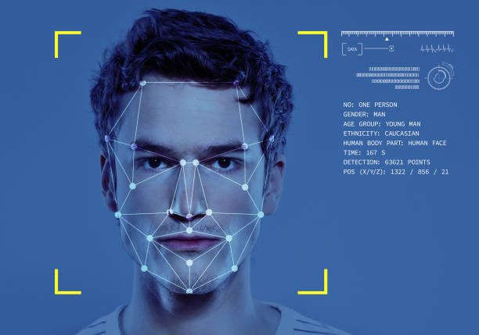

Additionally, face recognition has been used to target people [engaging in protected speech](http://www.baltimoresun.com/news/maryland/crime/bs-md-geofeedia-update-20161011-story.html). In the near future, face recognition technology will likely become more ubiquitous. It may be used to track individuals’ movements out in the world like automated license plate readers track vehicles by plate numbers. Real-time face recognition is already being used in [other countries](http://www.scmp.com/news/china/society/article/2115094/china-build-giant-facial-recognition-database-identify-any) and even at [sporting events](https://www.sporttechie.com/facial-recognition-technology-tested-lpga-nhl-next/) in the United States.

**There are 3 approaches for face recognition**

**A.- Feature base approach--** In feature based mostly approach the native options like nose, eyes square measure segmental and it will be used as input file in face detection.

**B.-Holistic approach--** In holistic approach the entire face taken because the input within the face detection system to perform face recognition.

**C.-Hybrid approach--**Hybrid approach is combination of feature based mostly and holistic approach. during this approach each native and whole face is employed because the input to face detection system.

**7.1 TECHNIQUES OF FACE RECOGNITION**

**1. Neural Networks--**

The neural networks square measure utilized in several applications like pattern recognition issues, character recognition, seeing, and autonomous mechanism driving. the most objective of the neural network within the face recognition is that the feasibility of training a system to capture the complicated category of face patterns. To urge the most effective performance by the neural network, it's to be extensively tuned range of layers, range of nodes, learning rates, etc. The neural networks square measure non linear within the network therefore it's wide used technique for face recognition. So, the feature extraction step could also be additional economical than the Principal element Analysis. The authors achieved ninety six.2% accuracy within the face recognition method once four hundred pictures of forty people. The classification time is a smaller amount than zero.5 second, however the coaching time is as long as four hours options in an exceedingly hierarchical set of layers and provides partial changelessness to translation, rotation, scale, and deformation. The disadvantage of the neural network approach is that once the amount of categories will increase . Multi- Layer Perceptron (MLP) with a feed forward learning algorithms was chosen for the projected system for its simplicity and its capability in supervised pattern matching. it's been with success applied to several pattern classification issues. A brand new approach to face detection with Dennis Gabor wavelets & feed forward neural network was given. The strategy used Dennis Gabor wave remodel and feed forward. The experimental results have shown that projected technique achieves higher results compared to different in algorithmic rule just like the graph matching and Eigen faces ways. a brand new category of convolutional neural network was projected wherever the process cells square measure shunting restrictive neurons. antecedently shunting restrictive neurons are utilized in standard feed forward design for classification and non-linear regression and were shown to be additional powerful than MLPs i.e. they will approximate complicated call surfaces way more pronto than MLPs. A hybrid neural network was presented which is a combination of local image sampling, a self-organized map neural network, and a convolutional network.

**2. Template Matching:--**

In example matching, we tend to are ready to exploit various face templates from entirely completely different prospects to characterize single face. Primarily, grey levels that match the face image can also be processed in correct format (Bichsel, 1991). In Bruneli and Poggio (1993) the Pop and Bruneli is gettable for all aspects of developing automatic four example choices i.e., eyes, nose, mouth, face and selecting the entire set. The system is evaluated by examination results from geometrical primarily based algorithms on 188 photos of forty seven subjects. The pattern matching formula is also a very smart approach, really straightforward to use and around achieves one hundred pc recognition rate. The Principal half Analysis victimization Eigen face provides the linear arrangement of templates. The foremost advantage of this approach is that it's easy to implement and may be a smaller quantity big-ticket than the opposite feature classifier. Relatively, example primarily based algorithms unit of measurement costlier and cannot be merely processed. However, the recognition methodology is well handled between the given example and input image.

**3.Geometrical Feature Matching:--**

Geometrical feature matching techniques unit of measuring supported the computation of a bunch of geometrical decisions from the image of a face. the ultimate configuration area unit delineate by a vector that representing the position and size of the foremost countenance like eyes and eyebrows, nose, mouth, and an overview of face. the first works on machine-controlled face recognition by victimization geometrical decisions was drained 1973.

Their system achieved seventy fifth recognition rate on an information of twenty individuals victimization 2 photos per person, one as a results of the model and to boot the selection as a results of the take a look at image. In 1993 R. Bruneli and T. Poggio, mechanically extracted a bunch of geometrical decisions from the image of a face, like nose breadth and length, mouth position and chin kind. there are unit thirty five decisions extracted type A thirty five dimensional vector. The popularity was then performed with a Bayes classifier. They achieved recognition rate ninetieth on an information of forty seven individuals. I.J. Cox el introduced a mixture-distance technique that achieved ninety fifth recognition rate on a difficulty information of 685 people. Reference used man of science riffle decomposition to watch feature points for each face image that reduced the storage demand for the knowledge. Typically, 35-45 feature points per face were generated. Two Values, the topological price, and similarity price, were evaluated. the popularity accuracy of the correct person was eighty six and ninety four of the right person's faces were at intervals the prime 3 candidate matches. However, it's reaching to be obsessed to the accuracy of the feature location algorithms. Disadvantage of current machine-controlled face feature location algorithms don't offer a high degree of accuracy and wish right smart procedure time.

**7.2 How Face Recognition Works?**

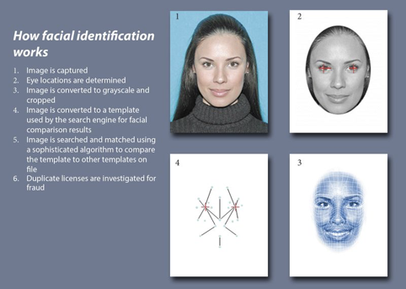

Source: Iowa Department of Transportation

Face recognition systems use computer algorithms to pick out specific, distinctive details about a person’s face. These details, such as distance between the eyes or shape of the chin, are then converted into a mathematical representation and compared to data on other faces collected in a face recognition database. The data about a particular face is often called a face template and is distinct from a photograph because it’s designed to only include certain details that can be used to distinguish one face from another.

Some face recognition systems, instead of positively identifying an unknown person, are designed to calculate a probability match score between the unknown person and specific face templates stored in the database. These systems will offer up several potential matches, ranked in order of likelihood of correct identification, instead of just returning a single result.

Face recognition systems vary in their ability to identify people under challenging conditions such as poor lighting, low quality image resolution, and suboptimal angle of view (such as in a photograph taken from above looking down on an unknown person).

When it comes to errors, there are two key concepts to understand:

A “false negative” is when the face recognition system fails to match a person’s face to an image that is, in fact, contained in a database. In other words, the system will erroneously return zero results in response to a query.

A “false positive” is when the face recognition system does match a person’s face to an image in a database, but that match is actually incorrect. This is when a police officer submits an image of “Joe,” but the system erroneously tells the officer that the photo is of “Jack.”

When researching a face recognition system, it is important to look closely at the “false positive” rate and the “false negative” rate, since there is almost always a trade-off. For example, if you are using face recognition to unlock your phone, it is better if the system fails to identify you a few times (false negative) than it is for the system to misidentify other people as you and lets those people unlock your phone (false positive). If the result of a misidentification is that an innocent person goes to jail (like a misidentification in a mugshot database), then the system should be designed to have as few false positives as possible.

**7.3 Current Research on Face Recognition And Techniques Available**

Key goal of computer vision researchers is to create automated face recognition systems that can equal, and eventually surpass, human performance. To this end, it is imperative that computational researchers know of the keyfindings from experimental studies of face recognition [1]. These findings provide insights into the nature of cues that the human visual system relies upon for achieving its impressive performance and serve as the building blocks for efforts to artificially emulate these abilities.

The face recognition problem has been studied for more than two decades. The approaches proposed in the literature so far can mainly be classified into two categories: model based and appearance based as described by Fu Jie Huang and Zhihua Zhou [5]. The model based method tries to extract geometrical parameters measuring the facial parts while the appearance based approach use the intensity or intensity-derived parameters such as eigen faces coefficients to recognize faces. Due to the changes of lighting condition, expression, occlusion, rotation, etc., the human face appearance could change considerably.

There are existing approaches proposed to recognize faces under varying pose. One is the Active Appearance Model proposed by Cootes [5], which deforms a generic face model to fit with the input image and uses the control parameters as the feature vector to be fed to the classifier.

The second approach is based on transforming an input image to the same pose as the stored prototypical faces and then using direct template matching to recognize faces, proposed by Beymer, Poggio and later extended by Vetter . The third method is the eigenspace from all of the different views, proposed by Murase and Nayar, and later used by Graham and Allinson in face recognition.

**8.CRIMINAL FACE RECOGNITION**

Face Recognition for Criminal Identification is a face recognition system in which the security expert will input an image of the person in question inside the system and the system will first preprocess the image which will cause unwanted elements such as noise to be removed from the image. After that, the system will then classify the image based on its landmarks for example, the distance between the eyes, the length of the jaw line, etc. Then, the system will run a search through the database to find its perfect match and display the output. This work is focusing on implementing the system for criminal identification. Current practice of thumbprint identification which is simple and easy to be implemented can be challenge by the use of latent thumbprint and sometimes cannot be acquired from the crime scene. The criminals have become cleverer and normally be very careful in leaving any thumbprint on the scene. This system encompassed face database and an image processing algorithm to match the face feed with faces stored in the database.

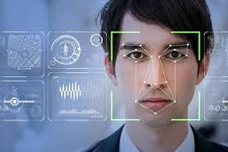

There are two parts vital to the success of this system; detection and recognition. A face detection is one of the most important steps in a face recognition system and can be classified into four principle categories; knowledge based, feature invariant, template matching and appearance-based methods [4]. In recognition, two stages are required; training process and evaluation process. In a training process, the algorithm is fed samples of the images to be learned and a distinct model for each image is determined while in an evaluation process, a model of a newly acquired test image is compared against all existing models in the database. Then the near corresponding model is acquired to determine whether the recognition is triggered. In this stage, a statistical procedure, Principal Component Analysis (PCA) is used to on a collection of face images to form a set of basis features, which is called a set of eigenfaces. Any human face can be considered to be a combination of these standard face.

**9.INTRODUCTION TO BASIC TERMS USED IN PROJECT**

**9.1 Python:**

**Python** is a high-level, interpreted, interactive and object-oriented scripting language. Python is designed to be highly readable. It uses English keywords frequently where as other languages use punctuation, and it has fewer syntactical constructions than other languages.

**Python** is a MUST for students and working professionals to become a great Software Engineer specially when they are working in Web Development Domain. I will list down some of the key advantages of learning Python:

* **Python is Interpreted** − Python is processed at runtime by the interpreter. You do not need to compile your program before executing it. This is similar to PERL and PHP.
* **Python is Interactive** − You can actually sit at a Python prompt and interact with the interpreter directly to write your programs.
* **Python is Object-Oriented** − Python supports Object-Oriented style or technique of programming that encapsulates code within objects.
* **Python is a Beginner's Language** − Python is a great language for the beginner-level programmers and supports the development of a wide range of applications from simple text processing to WWW browsers to games.

**9.2 Tkinter:**

Tkinter tutorial provides basic and advanced concepts of Python Tkinter. Our Tkinter tutorial is designed for beginners and professionals. Python provides the standard library Tkinter for creating the graphical user interface for desktop based applications.

Developing desktop based applications with python Tkinter is not a complex task. An empty Tkinter top-level window can be created by using the following steps.

* import the Tkinter module.
* Create the main application window.
* Add the widgets like labels, buttons, frames, etc. to the window.
* Call the main event loop so that the actions can take place on the user's computer screen.

**10.OpenCv**

OpenCV was started at Intel in 1999 by Gary Bradsky, and the first release came out in 2000. Vadim Pisarevsky joined Gary Bradsky to manage Intel's Russian software OpenCV team. In 2005, OpenCV was used on Stanley, the vehicle that won the 2005 DARPA Grand Challenge. Later, its active development continued under the support of Willow Garage with Gary Bradsky and Vadim Pisarevsky leading the project. OpenCV now supports a multitude of algorithms related to Computer Vision and Machine Learning and is expanding day by day.

OpenCV supports a wide variety of programming languages such as C++, Python, Java, etc., and is available on different platforms including Windows, Linux, OS X, Android, and iOS. Interfaces for high-speed GPU operations based on CUDA and OpenCL are also under active development.



**OpenCV-Python** is the Python API for OpenCV, combining the best qualities of the OpenCV C++ API and the Python language.

OpenCV-Python is a library of Python bindings designed to solve computer vision problems.

Python is a general purpose programming language started by Guido van Rossum that became very popular very quickly, mainly because of its simplicity and code readability. It enables the programmer to express ideas in fewer lines of code without reducing readability.

Compared to languages like C/C++, Python is slower. That said, Python can be easily extended with C/C++, which allows us to write computationally intensive code in C/C++ and create Python wrappers that can be used as Python modules. This gives us two advantages: first, the code is as fast as the original C/C++ code (since it is the actual C++ code working in background) and second, it easier to code in Python than C/C++. OpenCV-Python is a Python wrapper for the original OpenCV C++ implementation.

OpenCV-Python makes use of Numpy, which is a highly optimized library for numerical operations with a MATLAB-style syntax. All the OpenCV array structures are converted to and from Numpy arrays. This also makes it easier to integrate with other libraries that use Numpy such as SciPy and Matplotlib

**11.Classifier Cascades**

The definition of a **cascade** is a series of waterfalls coming one after another. A similar concept is used in computer science to solve a complex problem with simple units. The problem here is reducing the number of computations for each image.

To solve it, Viola and Jones turned their strong classifier (consisting of thousands of weak classifiers) into a cascade where each weak classifier represents one stage. The job of the cascade is to quickly discard non-faces and avoid wasting precious time and computations.

When an image subregion enters the cascade, it is evaluated by the first stage. If that stage evaluates the subregion as positive, meaning that it thinks it’s a face, then the output of the stage is *maybe*.

If a subregion gets a *maybe*, then it is sent to the next stage of the cascade. If that one gives a positive evaluation, then that’s another *maybe*, and the image is sent to the third stage.

This process is repeated until the image passes through all stages of the cascade. If all classifiers approve the image, then it is finally classified as a human face and is presented to the user as a detection.

If, however, the first stage gives a negative evaluation, then the image is immediately discarded as not containing a human face. If it passes the first stage but fails the second stage, then it is discarded as well. Basically, the image can get discarded at any stage of the classifier.

This is designed so that non-faces get discarded very quickly, which saves a lot of time and computational resources. Since every classifier represents a feature of a human face, a positive detection basically says, “Yes, this subregion contains all the features of a human face.” But as soon as one feature is missing, it rejects the whole subregion.

To accomplish this effectively, it’s important to put your best performing classifiers early in the cascade. In the Viola-Jones algorithm, the eyes and nose bridge classifiers are examples of best performing weak classifiers.

**11.1 Haar Cascade**

*It is an Object Detection Algorithm used to identify faces in an image or a real time video*. The algorithm uses edge or line detection features proposed by Viola and Jones in their research paper “Rapid Object Detection using a Boosted Cascade of Simple Features” published in 2001. The algorithm is given a lot of positive images consisting of faces, and a lot of negative images not consisting of any face to train on them. The model created from this training is available at the OpenCV GitHub repository <https://github.com/opencv/opencv/tree/master/data/haarcascades>.

The repository has the models stored in XML files, and can be read with the OpenCV methods. These include models for face detection, eye detection, upper body and lower body detection, license plate detection etc. Below we see some of the concepts proposed by Viola and Jones in their research.

***Features***

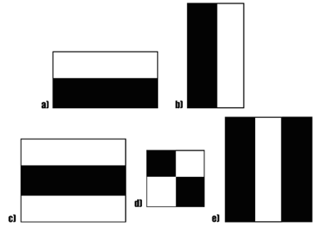

*Fig. A sample of Haar features used in the Original Research Paper published by Viola and Jones.*

The first contribution to the research was the introduction of the haar features shown above. These features on the image makes it easy to find out the edges or the lines in the image, or to pick areas where there is a sudden change in the intensities of the pixels.

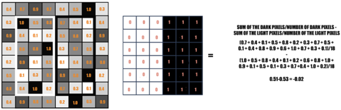

*Fig. The rectangle on the left is a sample representation of an image with pixel values 0.0 to 1.0. The rectangle at the center is a haar kernel which has all the light pixels on the left and all the dark pixels on the right. The haar calculation is done by finding out the difference of the average of the pixel values at the darker region and the average of the pixel values at the lighter region. If the difference is close to 1, then there is an edge detected by the haar feature.*

A sample calculation of Haar value from a rectangular image section has been shown here. The darker areas in the haar feature are pixels with values 1, and the lighter areas are pixels with values 0. Each of these is responsible for finding out one particular feature in the image. Such as an edge, a line or any structure in the image where there is a sudden change of intensities. For ex. in the image above, the haar feature can detect a vertical edge with darker pixels at its right and lighter pixels at its left.

The objective here is to find out *the sum of all the image pixels lying in the darker area of the haar feature* and *the sum of all the image pixels lying in the lighter area of the haar feature*. And then find out their difference. Now if the image has an edge separating dark pixels on the right and light pixels on the left, then the haar value will be closer to 1. That means, we say that there is an edge detected if the haar value is closer to 1. In the example above, there is no edge as the haar value is far from 1.

This is just one representation of a particular haar feature separating a vertical edge. Now there are other haar features as well, which will detect edges in other directions and any other image structures. To detect an edge anywhere in the image, the haar feature needs to traverse the whole image.



*Fig. The GIF shows how a haar feature traverses on an image from its left towards its right.*

The haar feature continuously traverses from the top left of the image to the bottom right to search for the particular feature. This is just a representation of the whole concept of the haar feature traversal. In its actual work, the haar feature would traverse pixel by pixel in the image. Also all possible sizes of the haar features will be applied.

Depending on the feature each one is looking for, these are broadly classified into three categories. The first set of *two rectangle features* are responsible for finding out the edges in a horizontal or in a vertical direction (as shown above). The second set of *three rectangle features* are responsible for finding out if there is a lighter region surrounded by darker regions on either side or vice-versa. The third set of *four rectangle features* are responsible for finding out change of pixel intensities across diagonals.

Now, the haar features traversal on an image would involve a lot of mathematical calculations. As we can see for a single rectangle on either side, it involves 18 pixel value additions (for a rectangle enclosing 18 pixels). Imagine doing this for the whole image with all sizes of the haar features. This would be a hectic operation even for a high performance machine.



*Fig. The GIF shows the making of an Integral Image. Each pixel in an Integral image is the sum of all the pixels in its left and above.*

To tackle this, they introduced another concept known as *The Integral Image* to perform the same operation. An Integral Image is calculated from the Original Image in such a way that each pixel in this is the sum of all the pixels lying in its left and above in the Original Image. The calculation of a pixel in the Integral Image can be seen in the above GIF. The last pixel at the bottom right corner of the Integral Image will be the sum of all the pixels in the Original Image.

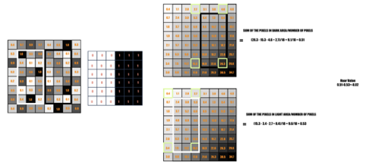

*Fig. Integral Image is used here to calculate the haar value.*

With the Integral Image, only 4 constant value additions are needed each time for any feature size (with respect to the 18 additions earlier). This reduces the time complexity of each addition gradually, as the number of additions does not depend on the number of pixels enclosed anymore.

In the above image, there is no edge in the vertical direction as the haar value is -0.02, which is very far from 1. Let’s see one more example, where there might be an edge present in the image.

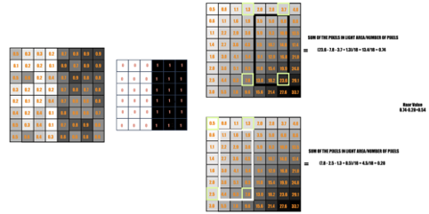

*Fig. Haar calculation from Integral Image. This is a case where there is a sudden change of pixel intensities moving vertically from the left towards the right in the image.*

Again repeating the same calculation done above, but this time just to see what haar value is calculated when there is a sudden change of intensities moving from left to right in a vertical direction. The haar value here is 0.54, which is closer to 1 in comparison to the case earlier.

Face Encoding

Algorithm that estimates a 3D textured model of a face from one image, applying a new facial “texture” to the estimated 3D model. The estimations also include relevant parameters of the scene, such as the orientation in 3D, the camera’s focal length, position, and illumination intensity and direction. The algorithm resembles the Morphable Model such that it optimizes all parameters in the model in conversion from 3D to image. Bitouk et al. [[9](https://jis-eurasipjournals.springeropen.com/articles/10.1186/s13635-020-00109-8#ref-CR9)] bring the idea of face replacement without the use of 3D reconstruction techniques. The approach involves the finding of a candidate replacement face which has similar appearance attributes to an input face. It is, therefore, necessary to create a large library of images. A ranking algorithm is then used in selecting the image to be replaced from the library. To make the swapped face more realistic, lighting and color properties of the candidate images might be adjusted. Their system is able to create subjectively realistic swapped faces. However, one of the biggest limitations is that it is unable to swap an arbitrary pair of faces. Mahajan et al. [[10](https://jis-eurasipjournals.springeropen.com/articles/10.1186/s13635-020-00109-8#ref-CR10)] present an algorithm that automatically chooses faces that are facing the front and then replaces them with stock faces in a similar fashion as Bitouk et al. [[9](https://jis-eurasipjournals.springeropen.com/articles/10.1186/s13635-020-00109-8#ref-CR9)].

Chen et al. [[11](https://jis-eurasipjournals.springeropen.com/articles/10.1186/s13635-020-00109-8#ref-CR11)] suggested an algorithm that can be used in the replacement of faces in referenced images that have common features and shape as the input face. A triangulation-based algorithm is used in warping the image by adjusting the reference face and its accompanying background to the input face. A parsing algorithm is used in accurate detection of face ROIs, and then, the Poisson image editing algorithm is finally used in the realization of boundaries and color correction. Poisson editing is explored from its basics by Perez et al. [[12](https://jis-eurasipjournals.springeropen.com/articles/10.1186/s13635-020-00109-8#ref-CR12)]. Once given methods to craft a Laplacian over some domain for an unknown function, a numerical solution of the Poisson equation for seamless domain filling is calculated. This technique can independently be replicated in color image channels.

The empirical success of deep learning in image processing has also resulted in many new face swapping techniques. Korshunova et al. [[13](https://jis-eurasipjournals.springeropen.com/articles/10.1186/s13635-020-00109-8#ref-CR13)] approached face swapping as a style transfer task. They consider pose and facial expression as the content and identity as the style. A convolutional neural network with multi-scale branches working on different resolutions of the image is used for transformation. Before and after the transformation, face alignment is conducted using the facial keypoints. Nirkin et al. [[4](https://jis-eurasipjournals.springeropen.com/articles/10.1186/s13635-020-00109-8#ref-CR4)] proposed a system that allows face swapping in more challenging conditions (two faces may have very different pose and angle). They applied a multitude of techniques to capture facial landmarks for both the source image and the target image, building 3D face models that allow swapping to occur via transformations. A fully convolutional neural network (FCN) is used for segmentation and for blending technique after transformation.

The popularity of auto-encoder[[3](https://jis-eurasipjournals.springeropen.com/articles/10.1186/s13635-020-00109-8#ref-CR3)] and generative adversarial networks (GANs) [[1](https://jis-eurasipjournals.springeropen.com/articles/10.1186/s13635-020-00109-8#ref-CR1)] makes face swapping more automated, requiring less expert supervision. A variant of the DeepFake project is based on these two techniques [[5](https://jis-eurasipjournals.springeropen.com/articles/10.1186/s13635-020-00109-8#ref-CR5)]. The input and output of an auto-encoder is fixed, and a joint latent space is discovered. During training, one uses this latent space to recover the original image of two (or more) individuals. Two different auto-encoders are trained on two different people, sharing the same encoder so that the latent space is learned jointly. This training incentivizes the encoder to capture some common properties of the faces (such as pose and relative expression). The decoders, on the other hand, are separate for each individual so that they can learn to generate realistic images of a given person from the latent space. Face swapping happens when one encodes person A’s face, but then uses person B’s decoder to construct a face from the latent space. A variant of this method in [[5](https://jis-eurasipjournals.springeropen.com/articles/10.1186/s13635-020-00109-8#ref-CR5)] uses an auto-encoder as a generator and a CNN as the discriminator that checks if the face is real or swapped. Empirical results show that adding this adversarial loss improves the quality of swapped faces.

Natsume et al. [[14](https://jis-eurasipjournals.springeropen.com/articles/10.1186/s13635-020-00109-8#ref-CR14)] suggest an approach that uses hair and faces in the swapping and replacement of faces in the latent space. The approach applies a generative neural network referred to as an RS-GAN (region-separative generative adversarial network) in the generation of a single face-swapped image. Dale et al. [[15](https://jis-eurasipjournals.springeropen.com/articles/10.1186/s13635-020-00109-8#ref-CR15)] bring in the concept of face replacement in a video setting rather than in an image. In their work, they use a simple acquisition process in the replacement of faces in a video using inexpensive hardware and less human intervention.

Fake face detection

Zhang et al. [[16](https://jis-eurasipjournals.springeropen.com/articles/10.1186/s13635-020-00109-8#ref-CR16)] created swapped faces using the labeled faces in the wild (LFW) dataset [[17](https://jis-eurasipjournals.springeropen.com/articles/10.1186/s13635-020-00109-8#ref-CR17)]. They used speeded up robust features (SURF) [[18](https://jis-eurasipjournals.springeropen.com/articles/10.1186/s13635-020-00109-8#ref-CR18)] and Bag of Words (BoW) to create image features instead of using raw pixels. After that, they tested on different machine learning models like random forests, SVMs, and simple neural networks. They were able to achieve accuracy over 92%, but did not investigate beyond their proprietary swapping techniques. The quality of their swapped faces is not compared to other datasets. Moreover, their dataset only has 10,000 images (half swapped) which is relatively small compared to other works.

Khodabakhsh et al. [[19](https://jis-eurasipjournals.springeropen.com/articles/10.1186/s13635-020-00109-8#ref-CR19)] examined the generalization ability of previously published methods. They collected a new dataset containing 53,000 images from 150 videos. The swapped faces in their dataset were generated using different techniques. Both texture-based and CNN-based fake face detection were evaluated. Smoothing and blending were used to make the swapped face more photo-realistic. However, the use of video frames increases the similarity of images, therefore decreasing the variety of images. Agarwal et al. [[20](https://jis-eurasipjournals.springeropen.com/articles/10.1186/s13635-020-00109-8#ref-CR20)] proposed a feature encoding method called Weighted Local Magnitude Patterns. They targeted videos instead of still images. They also created their own dataset. Korshunov et al. also targeted swapped faces detection in video [[21](https://jis-eurasipjournals.springeropen.com/articles/10.1186/s13635-020-00109-8#ref-CR21)]. They evaluated several detection methods of DeepFakes. What is more, they analyze the vulnerability of VGG- and FaceNet-based face recognition systems.

A recent work from Rössler et al. [[22](https://jis-eurasipjournals.springeropen.com/articles/10.1186/s13635-020-00109-8#ref-CR22)] provides an evaluation of various detectors in different scenarios. They also report human performance on these manipulated images as a baseline. Our work shares many similarities with these works. The main difference is that we provide a large-scale dataset created using still images instead of videos, avoiding image similarity issues. Moreover, we provide around 1000 different images in the wild for each celebrity. This is useful for models like auto-encoders that require numerous images for proper training. In this aspect, our dataset could be used beyond fake face detection. The second difference is that we are not only providing accuracy from human subjects, but also providing the rankings of images from most real to most fake. We compare this ranking to the score margin ranking of our classifier showing that human certainty and classifier certainty are relatively (but not identically) correlated.

Experiment

Dataset

Face swapping methods based on auto-encoding typically require numerous images from the same identity (usually several hundreds). There was no such dataset that met this requirement when we conducted this study; thus, we decided to create our own. Access to version 1.0 of this dataset is available for academic research use per request at the noted link[Footnote1](https://jis-eurasipjournals.springeropen.com/articles/10.1186/s13635-020-00109-8#Fn1). The statistics of our dataset are shown in Table [1](https://jis-eurasipjournals.springeropen.com/articles/10.1186/s13635-020-00109-8#Tab1).

Table 1 Dataset statistics

[Full size table](https://jis-eurasipjournals.springeropen.com/articles/10.1186/s13635-020-00109-8/tables/1)

All our celebrity images are downloaded using the Google image API. After downloading these images, we run scripts to remove images without visible faces and remove duplicate images. Then, we perform cropping to remove extra backgrounds. Cropping was performed automatically and inspected visually for consistency. We created two types of cropped images as shown in Fig. [1](https://jis-eurasipjournals.springeropen.com/articles/10.1186/s13635-020-00109-8" \l "Fig1) (Left). One method for face swapping we employed (Nirkin’s method [[4](https://jis-eurasipjournals.springeropen.com/articles/10.1186/s13635-020-00109-8#ref-CR4)]) involves face detection and lighting detection, allowing the use of images with larger, more varied backgrounds. On the other hand, the Auto-Encoder-GAN (AE-GAN) [[5](https://jis-eurasipjournals.springeropen.com/articles/10.1186/s13635-020-00109-8#ref-CR5)] method is more sensitive to the background; thus, we eliminate as much background as possible. In a real deployment of such a method, a face detection would be run first to obtain a region of interest, then swapping would be performed within the region. In this study, for convenience, we crop the face first using a face detector as a pre-processing step.

Fig. 1

[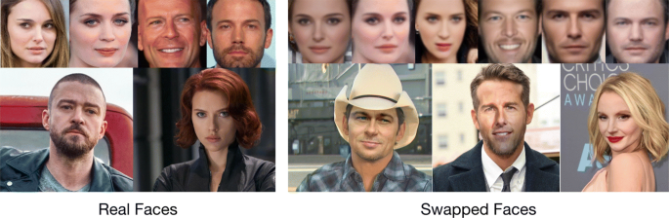](https://jis-eurasipjournals.springeropen.com/articles/10.1186/s13635-020-00109-8/figures/1)

Real and swapped faces in our dataset. Top row right: Auto-Encoder-GAN. Bottom row right: Nirkin’s method

[Full size image](https://jis-eurasipjournals.springeropen.com/articles/10.1186/s13635-020-00109-8/figures/1)

The two face swapping techniques we use in this study are representatives of many algorithms in use today. Nirkin’s method [[4](https://jis-eurasipjournals.springeropen.com/articles/10.1186/s13635-020-00109-8#ref-CR4)] is a pipeline of several individual techniques. On the other hand, the Auto-Encoder-GAN (AE-GAN) method is completely automatic, using a fully convolutional neural network architecture [[5](https://jis-eurasipjournals.springeropen.com/articles/10.1186/s13635-020-00109-8#ref-CR5)]. In selecting individuals to swap, we randomly pair celebrities within the same sex and skin tone. Each celebrity has around 1000 original images. For Nirkin’s method, once a pair of celebrities is chosen, we randomly choose one image from these 1000 images as the source image and randomly choose one from the other celebrity as the target image. We noticed, for Nirkin’s method, when the lighting conditions or head pose of two images differs too dramatically, the resulted swapped face is of low quality. On the other hand, the quality of swapped faces from the AE-GAN method is more consistent.

Classifier

Existing swapped face detection systems based on deep learning only provide an accuracy metric, which is insufficient for a classifier that is used continuously for detection. Providing an uncertainty level for each prediction is important for the deployment of such systems, especially when critical decisions need to be made based on these predictions.

In this study, we use the class probability produced by the softmax function for the final layer of the network for classification. We predict the class with the larger probability. For the binary classification problem, the winning class will have a probability of greater or equal to.5. Note that this is equivalent to choosing the class with the larger raw score (before applying softmax) and the raw score margin (i.e., the difference between the two classes) is proportional to the predicted class probability. For convenience, we will report score margins in this paper. We assume if the model is less certain about a prediction, the difference of these two scores should be smaller than that of a more certain prediction. We note that this method is extremely simple as compared to other models that explicitly try to model uncertainty of the neural network, such as Bayesian deep learning methods. The score margin, on the other hand, does not explicitly account for model uncertainty of the neural network—especially when images are fed into the network that are highly different from images from the training data. Even so, we find that the score margin is an effective measure of uncertainty for our dataset, though more explicit uncertainty models are warranted for future research.

Deep learning methods usually take days or weeks to train. Models like ResNet [[23](https://jis-eurasipjournals.springeropen.com/articles/10.1186/s13635-020-00109-8#ref-CR23)] can easily have tens or hundreds of layers. It is believed with more layers, more accurate hierarchical representation could be learned. Transfer learning allows us to reuse the learned parameters from one task to another similar task, thus avoiding training from scratch, which can save a tremendous amount of resources. In this study, we apply transfer learning using a ResNet model with 18 layers or ResNet-18, as described in the original paper [[23](https://jis-eurasipjournals.springeropen.com/articles/10.1186/s13635-020-00109-8#ref-CR23)], which is originally trained to perform object recognition on ImageNet [[24](https://jis-eurasipjournals.springeropen.com/articles/10.1186/s13635-020-00109-8#ref-CR24)]. We use the convolutional layers from ResNet-18 to process our images into a set of low-dimensional features (typically called the latent representation of the image). We note that no resizing of the images is needed since we use only the convolutional filters of the ResNet-18 architecture. These filters are used and can be applied to images of any size, which only changes the size of the outputs of the convolutions. Since we are performing binary classification in this study, we replace the final layers of ResNet-18 with custom dense layers and then train the model in stages. More specifically, we throw out the non-convolutional layers of ResNet-18, opting to train new layers to interpret the latent space feature representation of the images. During the first stage, we constrain the ResNet-18 architecture to be constant while the newly added layers are trained. After sufficient epochs, we then “fine tune” the ResNet-18 architecture, allowing the weights to be trained via back-propagation for a number of epochs. This method for implementing transfer learning on neural networks is also summarized by Shin et al. [[25](https://jis-eurasipjournals.springeropen.com/articles/10.1186/s13635-020-00109-8#ref-CR25)].

Human subjects

Because face swapping attacks are typically aimed at misleading observers, it is important to understand how human beings perform at detecting swapped faces. In this research, it is not only our aim to provide the accuracy of human subjects at detecting swapped faces, but also to establish a ranking of images from perceived as most real to most fake. For example, if a rater thinks that an image is fake, is it obvious or is that rater not quite sure about their decision? We argue that this uncertainty is important to model. Moreover, we argue that if fake images are visually unidentifiable, then the human ranking should be similar to the ranking produced by using the predicted score of the machine learning model.

For n images, we have 𝑛(𝑛−1)2n(n−1)2 pairs, and to get reliable rating data, we would have to elicit for each pair multiple ratings by different raters. This is impractical for even a modest number if images. Therefore, we apply two techniques to mitigate the ranking burden. First, we only rank a subset of the total images, and second, we perform approximate ranking of image pairs. As a subset of images, we manually select 100 high-quality swapped faces from each method together with 200 real faces (400 images in total). The manual selection of high-quality images is justified because badly swapped faces would be easily recognized. Thus, an attacker would likely perform the same manner of “re-selecting” only high-quality images before using them for a malicious purpose. It is of note that even with only 400 images and only considering a single rating per pair, the number of pairwise ratings required for ranking (over 79,000) poses a monumental task. The second technique is to use an active learning scheme that dynamically selects the most informative next image pair to compare for converging to an approximate ranking.

Active scheme for approximate ranking

To elicit the ranking, we designed and deployed a website that implements an adaptation of the approximate ranking algorithm Hamming-LUCB [[7](https://jis-eurasipjournals.springeropen.com/articles/10.1186/s13635-020-00109-8#ref-CR7)] to the specific application of swapped face detection. The input and output of the algorithm are based on “crowd sourced” comparisons made on our website by a large number of users. Users on the website are asked to compare two images and select which image they think is more likely to be fake. The idea is that different users are more likely to select a clearly fake looking image, while they will disagree more when the two images both look real. This is exactly the type of information that is needed to create the consensus ranking. We use approximate ranking with active comparison selection because of the impractical number of pairwise comparisons that would be required for an exact ranking using passive comparison selection.

For a set of [n]={1,2,…,n} of n images, Hamming-LUCB seeks to estimate an approximate ranking by assigning each image i∈[n] a ranking score τi that is sufficiently accurate to identify two ordered sets of images S1 and S2, representing the highest and lowest ranked images, respectively. Subsets S1 and S2 consist of a range of items of size k−h, where h is a predefined number of allowable “mistakes” in each set, and the n−k−h items. Images in S1 are perceived as most fake, while images in S2 are perceived as least fake. Between the two sets, there is a high confidence that the items contained in the first set score higher as compared to those items that are contained in the second set.

The main goal of the algorithm is collect enough information to estimate the image ranking score for each image to be able to identify the two sets, S1 and S2, given a required confidence. In each iteration, the algorithm determines which pair of items to present for comparison based on the outcomes of previous comparisons. In this strategy, the current score estimations and the intervals of confidence associated with the scores are the parameters underlying the decision about which images to compare next. The result is an approximate ranking that is most accurate for images that are on the borderline between S1 and S2, i.e., images that do not look too fake, but also not too real. For more details about the algorithm and its implementation, we refer the reader to [[7](https://jis-eurasipjournals.springeropen.com/articles/10.1186/s13635-020-00109-8#ref-CR7)].

Website ratings collection

The inspiration of our website comes from that of the GIFGIF project for ranking emotions of GIFs[Footnote2](https://jis-eurasipjournals.springeropen.com/articles/10.1186/s13635-020-00109-8#Fn2). Figure [2](https://jis-eurasipjournals.springeropen.com/articles/10.1186/s13635-020-00109-8#Fig2) shows a screenshot of the website. The text “Which of the following two faces looks MORE FAKE to you” is displayed above two images. When the evaluator moves the mouse above either image, it is highlighted with a box. The evaluator could choose to login using a registered account or stay as an anonymous evaluator. In this website, there are two instances of Hamming-LUCB running independently for two investigated face swapping algorithms, AE-GAN and Nirkin’s method. The probability of selecting either swapped type is 50%. Over a 3-month period, we recruited volunteers to rate the images. When a new rater is introduced to the website, they first undergo a tutorial and example rating to ensure they understand the selection process. We collected 36,112 comparisons in total from more than 90 evaluators who created login accounts on the system. We note that anyone using the system anonymously (without logging in) was not tracked, so we do not know exactly how many different evaluators used the website.

Fig. 2

[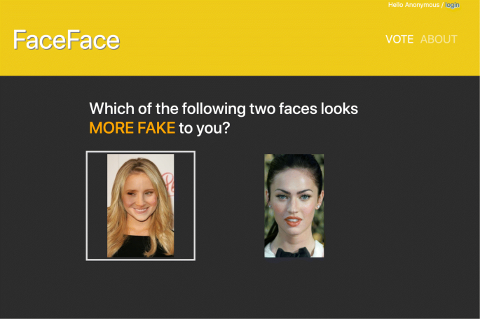](https://jis-eurasipjournals.springeropen.com/articles/10.1186/s13635-020-00109-8/figures/2)

A screenshot of the website collecting pairwise comparisons. As the mouse hovers over the left image, it is highlighted

[Full size image](https://jis-eurasipjournals.springeropen.com/articles/10.1186/s13635-020-00109-8/figures/2)

Results

To evaluate the performance of our classifier, we have separated train and test by person (i.e., celebrity). That is, if a person has images in the training set, they do not have images in the testing set. In this way, the algorithm cannot learn specifics of a person’s face but, instead, must rely on learning generalizing artifacts within swapped face images. We used the default hyperparameters and a fixed number of epochs for models, and therefore, there was no need for a separate validation dataset. Also, we do not distinguish between the two types of swapped faces during training. In other words, we mix the swapped faces generated using both methods during training, but we report prediction performance on each method separately.

Table [2](https://jis-eurasipjournals.springeropen.com/articles/10.1186/s13635-020-00109-8#Tab2) gives the overall detection performance of our classifier for the entire dataset (5-fold cross-validation) and for the 400 images that were ranked by human subjects (using the entire dataset for training, but not including these 400 images). We also report the accuracy with which humans were able to select images as real or fake based on the pairwise ranking. That is, any fake images ranked in the top 50% or any real images ranked in the bottom 50% were considered as errors. From the table, we can see that both human subjects and the classifier achieve good accuracy when detecting swapped faces. Our classifier is able to achieve comparable results to human subjects in 200 manually selected representative images (100 fake, 100 real) for each method.

Table 2 Overall results

[Full size table](https://jis-eurasipjournals.springeropen.com/articles/10.1186/s13635-020-00109-8/tables/2)

To test the generalizability of our model, we also use the Chicago Face Dataset[Footnote3](https://jis-eurasipjournals.springeropen.com/articles/10.1186/s13635-020-00109-8#Fn3) (CFD). It provides high-resolution standardized photographs of male and female faces of different ages and varying ethnicity. The CFD also provides photographs of faces of different expressions for a subset of targets (neutral, happy, fearful, etc). For these targets that have more than one expression, we only use the photograph of the neutral expression. We used 600 real faces from CFD and generated 662 swapped faces using Nirkin’s method. Thus, we have 1262 faces in total as a separate testing set. It was not possible to generate swapped faces using AE-GAN method, as mentioned above, because AE-GAN requires hundreds of images for the same person (and is therefore only suitable for databases with numerous images of one person, like celebrities).

Classification accuracy

As we mentioned above, we created two types of cropped images for each method. The AE-GAN method contains minimal background, and Nirkin’s method contains more background. We can see from Table [2](https://jis-eurasipjournals.springeropen.com/articles/10.1186/s13635-020-00109-8#Tab2) that our classifier is able to detect face swapping better for the AE-GAN generated images—this holds true regardless of testing upon the entire dataset or using the manually selected 200. As we can see from Fig. [1](https://jis-eurasipjournals.springeropen.com/articles/10.1186/s13635-020-00109-8" \l "Fig1) (Right), the AE-GAN generates swapped faces that are slightly blurry, which we believe our model exploits for detection. On the other hand, Nirkin’s method could generate swapped faces without a decrease in sharpness. Thus, it may require the model to learn more subtle features, such as looking for changes in lighting condition near the cropped face or stretching of facial landmarks to align the perspectives.

When testing the Chicago Face Dataset, we use all the images in our celebrity dataset for training. Table [2](https://jis-eurasipjournals.springeropen.com/articles/10.1186/s13635-020-00109-8#Tab2) shows the results after a single epoch of training. As we can see, our model is generalizable to the non-celebrity faces in the Chicago Face Dataset, but performs slightly worse in terms of true positive rate and false alarm rate. However, we do not attribute this to celebrity status. Instead, we hypothesize that the reduced variability in lighting and relatively consistent head pose for the Chicago Face Dataset eases the process of swapping faces. That is, there is less inconsistency in the face for the model to find, resulting in reduced ability to detect swapped faces. Even so, the performance on the dataset is greater than 90.0%, which supports the conclusion that the model is robust to images from different sources, such as the Chicago Face Dataset.

For version 1.0 of the dataset, we have collected more than 36,112 pairwise comparisons from more than 90 evaluators (approximately evenly split between each method). Human subjects may have different opinions about a pair of images; thus, it requires many pairwise comparisons, especially for these images in the middle area. However, we can see human subjects still give a reasonable accuracy, especially for the AE-GAN method. It is interesting to see that both our classifier and human subjects perform better on the AE-GAN generated images.

Classifier visualization

To elucidate what spatial area our classifiers are concentrating upon to detect an image as real or fake, we employ the Gradient-weighted Class Activation Mapping (Grad-CAM) visualization technique [[26](https://jis-eurasipjournals.springeropen.com/articles/10.1186/s13635-020-00109-8#ref-CR26)]. This analysis helps mitigate the opaqueness of a neural network model and enhance explainability for applications in the domain of privacy and security. Grad-CAM starts by calculating the gradients of the score for class c (before the softmax) with respect to the feature maps of the last convolutional layer. The gradients are then global average-pooled as weights. By inspecting these weighted activation maps, we can see which portions of the image have significant influence in classification. For both types of generated swapped faces, our classifier focuses on the central facial area (i.e., the nose and eyes) rather than the background. This is also the case for real faces as we can see from Fig. [3](https://jis-eurasipjournals.springeropen.com/articles/10.1186/s13635-020-00109-8" \l "Fig3). We hypothesize that the classifier focuses on the nose and eyes because these areas contain more intricate details of faces. Figure [4](https://jis-eurasipjournals.springeropen.com/articles/10.1186/s13635-020-00109-8#Fig4) gives one such example. As we zoom in, we can see the blurring on the left side of the nose is slightly different from that on the right side. It is interesting that the eyes and nose are focused upon by the classifier because human gaze also tends to focus on the eyes and nose when viewing faces [[27](https://jis-eurasipjournals.springeropen.com/articles/10.1186/s13635-020-00109-8#ref-CR27)].

Fig. 3

[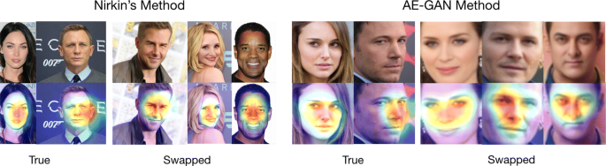](https://jis-eurasipjournals.springeropen.com/articles/10.1186/s13635-020-00109-8/figures/3)

Grad-CAM visualization of our proposed model on real and swapped faces. Top row: original images before fed into the network. Bottom row: original images with heatmap

[Full size image](https://jis-eurasipjournals.springeropen.com/articles/10.1186/s13635-020-00109-8/figures/3)

Fig. 4

[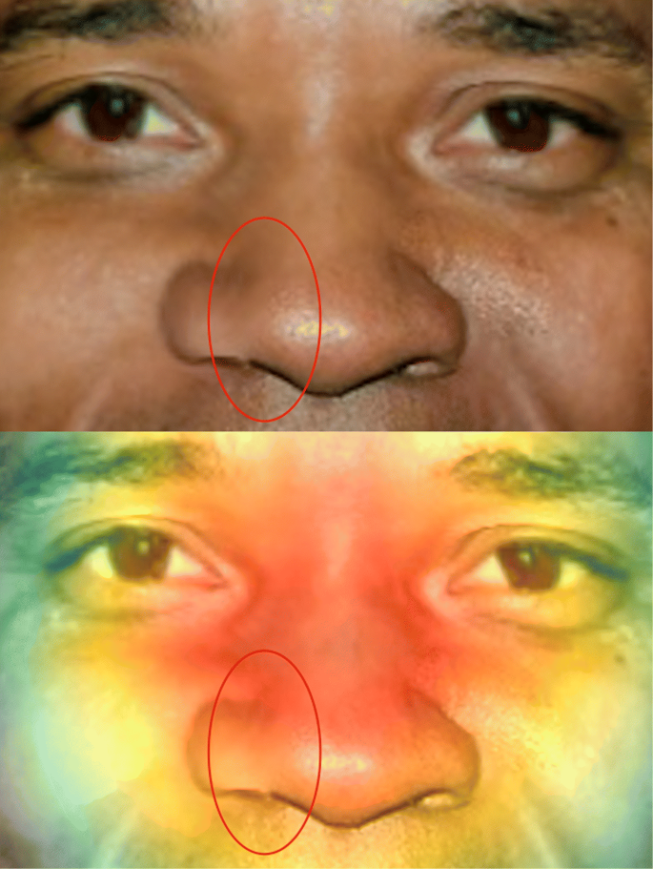](https://jis-eurasipjournals.springeropen.com/articles/10.1186/s13635-020-00109-8/figures/4)

An example of blurring difference contained on a nose from a swapped image

[Full size image](https://jis-eurasipjournals.springeropen.com/articles/10.1186/s13635-020-00109-8/figures/4)

Comparing image rankings

Rather than reporting only accuracy of detecting swapped faces from human subjects, we also compare the rankings. Ranking gives us more information to compare the models with humans, such as does the ResNet model similarly rate images that are difficult to rate for humans? Or, on the contrary, is the ranking from the model very different from human ranking?

Figure [5](https://jis-eurasipjournals.springeropen.com/articles/10.1186/s13635-020-00109-8#Fig5) gives the overall ranking for faces generated using two methods using the Hamming-LUCB consensus ranking from human evaluators. Red boxed points are false negatives, and black boxed points are false positives. The confidence interval based on the Hamming-LUCB is shown as the gray-shaded area. As we can see, human subjects have more difficulty classifying the faces generated using Nirkin’s method. As mentioned, the AE-GAN generated faces are blurrier compared with Nirkin’s method. Human subjects seemingly are able to learn such a pattern from previous experience. While some mistakes are present for the AE-GAN, these mistakes are very near the middle of the ranking. Swapped faces generated using Nirkin’s method keep the original resolution and are more photo-realistic—thus, they are also more difficult to discern as fake.

Fig. 5

[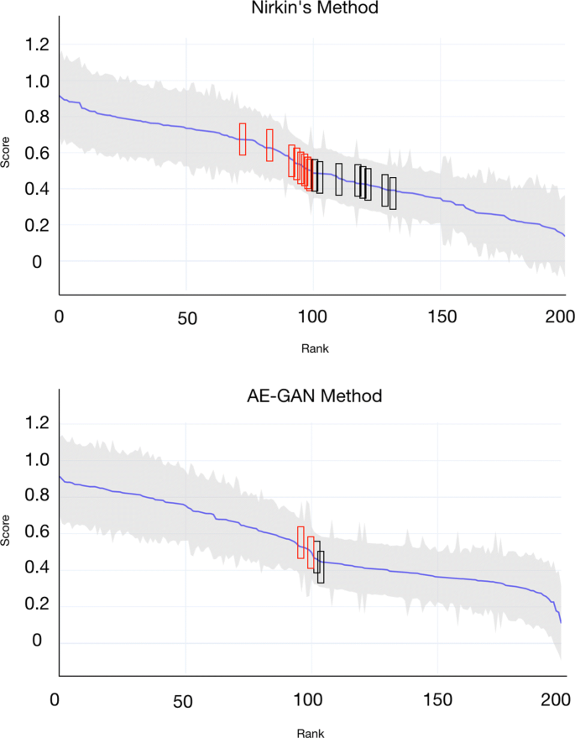](https://jis-eurasipjournals.springeropen.com/articles/10.1186/s13635-020-00109-8/figures/5)

Human subjects rank of the manually selected 200 images. Left to right, from most real to most fake

[Full size image](https://jis-eurasipjournals.springeropen.com/articles/10.1186/s13635-020-00109-8/figures/5)

To compare the human ranking to our model, we need to process the outputs of the neural network. During training, the model learns a representation of the input data using convolutions. Instances belonging to different classes usually are pushed away in a high-dimensional space. But this distance between two instances is not necessarily meaningful to interpret. Despite this, the output of the activation function can be interpreted as a relative probability that the instance belongs to each class.

We assume for the score margin of the last fully connected layer (before the softmax activation) that the wider the margin, the more confident the classifier is that the instance is real or fake (i.e., a measure of certainty). Figure [6](https://jis-eurasipjournals.springeropen.com/articles/10.1186/s13635-020-00109-8#Fig6) gives the comparison of score margin of our model and human rating (score) for the 200 faces used with each method. For Nirkin’s method, the Pearson correlation coefficient between the scores is 0.7896 and Spearman’s rank order correlation coefficient between the resulting rankings is 0.7579. For the AE-GAN Method, the Pearson correlation is 0.8332 and Spearman’s rank order correlation is 0.7576. However, the overall correlation may only indicate that these two classes are well separated by humans and the classifier. To eliminate this effect, we also give the correlation within each class to understand if the correlation is related to human perception or “realism.” For the AE-GAN method, the Pearson correlation coefficient is 0.2865 for the real faces and 0.0415 for the fake faces. Spearman’s rank order correlation is 0.1106 for the real faces and −0.0027 for the fake faces. For Nirkin’s method, the Pearson correlation is 0.3701 for the real faces and 0.4229 for the fake faces. Spearman’s rank order correlation is 0.1175 for the real faces and 0.3741 for the fake faces. This indicates that the certainty level of our model and human subjects rating is related, but not perfect—especially for fake images using the AE-GAN method where almost no correlation to humans is observed. We also notice the correlations for the real faces for Nirkin’s method and for the AEGAN methods are very close (around 0.09 difference). However, with about 50 data points in each calculation, the linear correlation is sensitive to relatively few outliers. Therefore, one cannot interpret these correlations in a conclusive way. Even so, the correlation in Nirkin’s method is encouraging because it shows the model learns not only a binary threshold, but captures some similarity in ranking of the images from most fake to most real. This analysis supports a conclusion that human ranking of realism may be easier to mimic than human ranking of “how fake” an image might be. We anticipate that future work can furtherimprove upon this ranking similarity.

[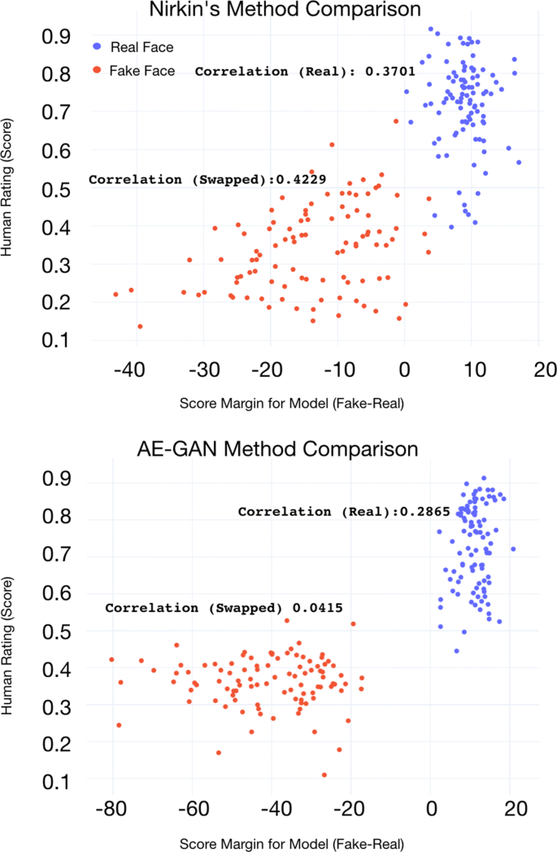](https://jis-eurasipjournals.springeropen.com/articles/10.1186/s13635-020-00109-8/figures/6)

**11.2. Frontal face haarcascade**

With **haarcascade_frontalface_default**.**xml,**we are using an inbuilt function with it called the **detectMultiScale.**

This function will help us to find the features/locations of the new image. The way it does is, it will use all the features from the **face_classifier**object to detect the features of the new image.

The parameters that we will pass to this function are:

1. The gray scale variable — gray in our case
2. **scaleFactor**— Parameter specifying how much the image size is reduced  
   at each image scale. Basically, the scale factor is used to create your scale pyramid. More explanation, your model has a fixed size defined during training, which is visible in the XML. This means that this size of the face is detected in the image if present. However, by rescaling the input image, you can resize a larger face to a smaller one, making it detectable by the algorithm. 1.05 is a good possible value for this, which means you use a small step for resizing, i.e. reduce the size by 5%, you increase the chance of a matching size with the model for detection is found. This also means that the algorithm works slower since it is more thorough. You may increase it to as much as 1.4 for faster detection, with the risk of missing some faces altogether. In our case, I have used 1.0485258 as the **scaleFactor**as this worked perfectly for the image that I was using.
3. **minNeighbors**— Parameter specifying how many neighbors each candidate rectangle should have to retain it. This parameter will affect the quality of the detected faces. Higher value results in fewer detections but with higher quality. 3~6 is a good value for it. In our case, I have taken 6 as the **minNeighbors** and this has worked perfectly for the image that I have used.

**12. Local Binary Pattern Histogram**

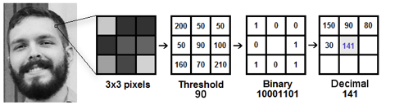

**LBPH (Local Binary Pattern Histogram)** is a Face-Recognition algorithm it is used to recognize the face of a person. It is known for its performance and how it is able to recognize the face of a person from both front face and side face.

Before starting the intuition behind the LBPH algorithm, let’s first understand a little bit about the basics of Images and pixels in order to understand how images are represented before we start the content about Face-Recognition. So let”s get started understanding images and pixels.

**Images & Pixel**

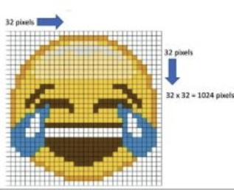

All images are represented in the Matrix formats, as you can see here, which are composed of rows and columns. The basic component of an image is the pixel. An image is made up of a set of pixels. **Each one of these is small squares. By placing them side by side, we can form the complete image. A single pixel is considered to be the least possible information in an image. For every image, the value of pixels ranges between 0 to 255.**

**This image here is 32 pixels wide and 32 pixels high.**

**And when we multiply 32 by 32, the result is 1024, which is the total number of pixels in the image. Each pixel is composed of** Three values are R, G, and B, which are the basic colours red, green, and blue. The combination of these three basic colours will create all these colours here in the image so we conclude that a single pixel has three channels, one channel for each one of the basic colours.

As now we have some understanding of images and pixels, now it will be easier to understand the intuition behind the LBPH algorithm. So let’s get started with the intuition of the LBPH algorithm

**LBPH(Local Binary Patterns Histograms)**

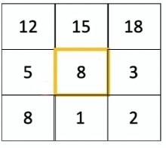

Let’s start by analyzing a matrix that represents a piece of the image. And as you learn earlier, an image is represented in these formats. In this example, we have three rows and three columns and the total number of pixels is nine. Let’s select the central pixel here, value eight, and apply a condition. If the value is greater or equal to 8, the result is ‘1’ otherwise, if the value is less than eight, the result is zero. After applying the conditioner, the matrix will now look like this.

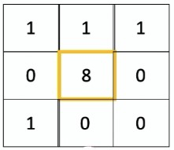

The basic calculation of this algorithm is to apply this condition, selecting the centre element of the matrix. Now we need to generate a binary value.**Binary value = 11100010 .** The algorithm will start applying the condition from the top left corner element goes up to the 1 element of the 2nd row think like it is making a circle like this.

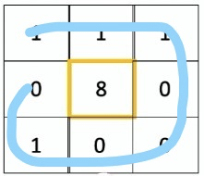

After converting the Binary value to the decimal value we get **Decimal Value = 226.** It indicates that all these pixels around the central value equal to 226.

This algorithm is robust when it comes to lightning. If you put a flashlight on the image, the value of the pixels will increase. Higher the values the brighter the image and when values are lower darker the image will be. For this reason, this algorithm has good results in light and dark images because when the image becomes lighter or darker, all the pixels in the neighbourhood here will be changed. After putting the light on the image the matrix will look like this. After applying the above condition we will get the binary value the same as above i.e **11100010**

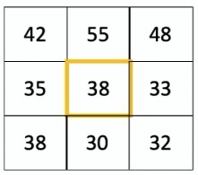

Let’s consider this another image here. In order to better understand how the algorithm will recognize a person’s face.

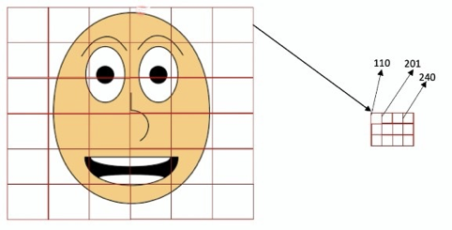

We have the image of a face here, and what the algorithm will do is create several squares, as you can see here. And within each one of these squares, we have the representation of the previous is light. For example, this square here does not represent only one pixel but is set with multiple pixels that are three rows and four columns. Three by four is equal to twelve pixels in total in these squares here in each of these squares that are twelve pixels. And then we apply that condition to each one. Considering the central pixel.

The next step is to create a histogram, which is a concept of statistics that will count how many times each color appears in each square. This is the representation of the histogram.

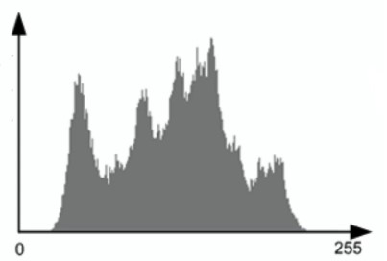

For example, if the value 110 appears 50 times a bar like this will be created with this size equal to 50, if 201 appears 110 times and the other bar will be created in this histogram with this size equal to 100. Based on the comparison of the histograms, the algorithm will be able to identify the edges and also the corners of the images. For example, in this first square here, we don’t have information about the person’s face. So the histogram will be different from this other square that has the border of the face. In short, the algorithm knows which histograms represent borders and which histograms represent the person’s main features, such as the colour of the eye, the shape of the mouth, and so on.

**12.CODING**

**#Front End:**

>>Crimminal_Detection_GUI.py

from tkinter import *

import os

from datetime import datetime;

root=Tk()

root.configure(background="white")

#root.geometry("300x300")

def function1():

os.system(" python create_data.py")

def function2():

os.system("python face_recognize.py")

def function3():

root.destroy()

#stting title for the window

root.title("project")

#creating a text label

Label(root, text="JECRC UNIVERSITY\nMINOR PROJECT\nCRIMMINAL FACE RECOGNITION\nSubmitted by Ashish swami(20MCLN009) and Prashant yadav(20MCIN007)\n Submitted to Mr. Shekhar Chandra sir",font=("times new roman",24),fg="black",bg="red",height=5).grid(row=0,rowspan=2,columnspan=2,sticky=N+E+W+S,padx=5,pady=5)

#creating first button

Button(root,text="Create Dataset",font=("times new roman",20),bg="white",fg='black',command=function1).grid(row=3,columnspan=2,sticky=W+E+N+S,padx=5,pady=5)

#creating second button

Button(root,text="Train and Detect",font=("times new roman",20),bg="white",fg='black',command=function2).grid(row=4,columnspan=2,sticky=W+E+N+S,padx=5,pady=5)

Button(root,text="Exit",font=('times new roman',20),bg="green",fg="black",command=function3).grid(row=9,columnspan=2,sticky=N+E+W+S,padx=5,pady=5)

root.mainloop()

**#Back End:**

1. **Database creation:**

>>create_data.py

#Creating database

import cv2, sys, numpy, os

haar_file = '/Users/Ashish/Desktop/project/haarcascade_frontalface_default.xml'

# All the faces data will be

datasets = '/Users/Ashish/Desktop/project/datasets'

sub_data = '/Users/Ashish/Desktop/project/datasets/ashish'

path = os.path.join(datasets, sub_data)

if not os.path.isdir(path):

os.mkdir(path)

# defining the size of images

(width, height) = (130, 100)

#'0' is used for my webcam

face_cascade = cv2.CascadeClassifier('/Users/Ashish/Desktop/project/haarcascade_frontalface_default.xml')

webcam = cv2.VideoCapture(0)

# The program loops until it has 30 images of the face.

count = 1

while count < 30:

(_, im) = webcam.read()

gray = cv2.cvtColor(im, cv2.COLOR_BGR2GRAY)

faces = face_cascade.detectMultiScale(gray, 1.3, 4)

for (x, y, w, h) in faces:

cv2.rectangle(im, (x, y), (x + w, y + h), (255, 0, 0), 2)

face = gray[y:y + h, x:x + w]

face_resize = cv2.resize(face, (width, height))

cv2.imwrite('%s/%s.jpg' % (path, count), face_resize)

count += 1

cv2.imshow('OpenCV', im)

key = cv2.waitKey(10)

if key == 27:

break

1. **Train and Detection:**

**>>face_recognize.py**

import cv2, sys, numpy, os

haar_file = '/Users/Ashish/Desktop/project/haarcascade_frontalface_default.xml'

# path to the main faces directory

datasets = '/Users/Ashish/Desktop/project/datasets'

print('Training classifier...')

# Creating a list of images and a list with a unique id

(images, labels, names, id) = ([], [], {}, 0)

for (subdirs, dirs, files) in os.walk(datasets):

for subdir in dirs:

names[id] = subdir

subjectpath = os.path.join(datasets, subdir)

for filename in os.listdir(subjectpath):

path = subjectpath + '/' + filename

label = id

images.append(cv2.imread(path, 0))

labels.append(int(label))

id += 1

(width, height) = (130, 100)

def rounded_rectangle(img, pt1, pt2, color, thickness, r, d):

x1,y1 = pt1

x2,y2 = pt2

# Top left

cv2.line(img, (x1 + r, y1), (x1 + r + d, y1), color, thickness)

cv2.line(img, (x1, y1 + r), (x1, y1 + r + d), color, thickness)

cv2.ellipse(img, (x1 + r, y1 + r), (r, r), 180, 0, 90, color, thickness)

# Top right

cv2.line(img, (x2 - r, y1), (x2 - r - d, y1), color, thickness)

cv2.line(img, (x2, y1 + r), (x2, y1 + r + d), color, thickness)

cv2.ellipse(img, (x2 - r, y1 + r), (r, r), 270, 0, 90, color, thickness)

# Bottom left

cv2.line(img, (x1 + r, y2), (x1 + r + d, y2), color, thickness)

cv2.line(img, (x1, y2 - r), (x1, y2 - r - d), color, thickness)

cv2.ellipse(img, (x1 + r, y2 - r), (r, r), 90, 0, 90, color, thickness)

# Bottom right

cv2.line(img, (x2 - r, y2), (x2 - r - d, y2), color, thickness)

cv2.line(img, (x2, y2 - r), (x2, y2 - r - d), color, thickness)

cv2.ellipse(img, (x2 - r, y2 - r), (r, r), 0, 0, 90, color, thickness)

# Create a numpy array from the lists above

(images, labels) = [numpy.array(lists) for lists in [images, labels]]

# OpenCV trains a model from the images using the Local Binary Patterns algorithm

model = cv2.face.LBPHFaceRecognizer_create()

# train the LBP algorithm on the images and labels we provided above

model.train(images, labels)

face_cascade = cv2.CascadeClassifier(haar_file)

webcam = cv2.VideoCapture(0)

print('Classifier trained!')

print('recognize faces...')

while True:

(_, im) = webcam.read()

gray = cv2.cvtColor(im, cv2.COLOR_BGR2GRAY)

# detectinng faces using the haar_cacade file

faces = face_cascade.detectMultiScale(gray, 1.3, 5)

for (x,y,w,h) in faces:

# colour = bgr format

# drawing a rectangle around the face and resizing/ grayscaling it

face = gray[y:y + h, x:x + w]

face_resize = cv2.resize(face, (width, height))

# try to recognize the face(s) using the resized faces made above

prediction = model.predict(face_resize)

rounded_rectangle(im, (x, y), (x + w, y + h), (0, 255, 255), 2, 15, 30)

# if face is recognized, display the corresponding name

if prediction[1] < 74:

cv2.putText(im,'Crimminal Detected',(x + 5, (y + 25) + h), cv2.FONT_HERSHEY_PLAIN,1.5,(65,65, 255), 2)

# print the confidence level with the person's name to standard output

confidence = (prediction[1]) if prediction[1] <= 100.0 else 100.0

else:

cv2.putText(im,'Not Crimminal',(x + 5, (y + 25) + h), cv2.FONT_HERSHEY_PLAIN,1.5,(20, 185, 20), 2)

#print("predicted person: Unknown")

cv2.imshow('OpenCV Face Recognition - esc to close', im)

key = cv2.waitKey(10)

# esc to quit

if key == 27:

break

**13. Testing**

The software testing is a very important element part of software quality assurance and represents the ultimate review of specification, design and code generation. The testing is important because it uncovers errors. Both Currency Converter and Monopoly game project has undergone testing. A number of inputs were given so that the outputs could be checked. Only after the errors were removed the software was finally implemented. Once the source code has been generated website must be tested to uncover as may errors as possible before delivery to customer. Testing is concerned about the inputs and their expected outputs. In testing data is inputed in website and the output is compared with the expected results.

Importance Of Testing:

Reviews and other activities can and do uncover errors, but they are not sufficient. Every time the program is executed, the customer tests it! Therefore, you have to execute the program before it gets to the customer with the specific intent of finding and removing all errors. In order to find the highest possible number of errors, test must be conducted systematically and test cases must be designed using disciplined techniques.

**13.1 System Testing:**

Software once validated, must be combined with other system element. System testing verifies that all mesh properly and that overall system functions are achieved. System testing is actually a series of different test whose primary purpose is fully exercising the computer base system. Although each test has different purpose, all work to verify that system elements have been properly integrated and perform allocated function.

System testing is performed at run time the system given appropriate massage at run time if user entered wrong data or does not enters data at all.

The System Testing has been carried out at three levels:-

-1 Level when the user enters wrong data of data which are not acceptable to the system due to validation.

+1 Level When the user is feeding the correction.

0 Level When the user not enters the data at a ect data and all is going well.

**13.2 Integration Testing:**

In this testing, all the modules together into special testing environment then checks for error, bugs and interoperability. It deals with test for the entire application. Application limits and features are tested in this testing.

Integration testing uncovers errors that arise when modules are integrated to build the overall system. Following types of errors may arise: -

Data can be lost across an interface.

Sub-function, when combined may not produce desired major function.

Individually expectable imprecision may be magnified to unacceptable labels.

**13.3 Recovery Testing:**

Recovery testing is a system test that forces the software to fail in a variety of ways and verifies that recovery is properly performed. We perform this testing by closing the application using the processing is running. We find that the stored record in the database is secured when we open this application again.

**13.4 Security Testing:**

For this testing, we try to break the password of entry. We find that, it is impossible or at least very difficult to break this password.

**13.5 Stress Testing:**

For this testing, we execute this application while the many other applications are running. This takes some time to load the application, but it works well once it is loaded. Therefore, we find that, this software is working properly in various conditions.

**14.Implementation**

The implementation can be presented in different phases.

**Process Logic:**

**14.1 Database creation Process**

* Open the Crimminal_Detection_GUI.py file
* Click on Create dataset button
* Webcam will be shown and captures the frame of face

**14.2 Training**

* Click on Train and Detect button
* New window will be shown and the module automatically trains the dataset

**14.3 Output Process**

* After clicking on Train and detect buton the new window will be shown
* The Windows will give output “Criminal” if the criminal is detected
* Or the windows will show “Not criminal” if not detected

**15.Snapshots of Project**

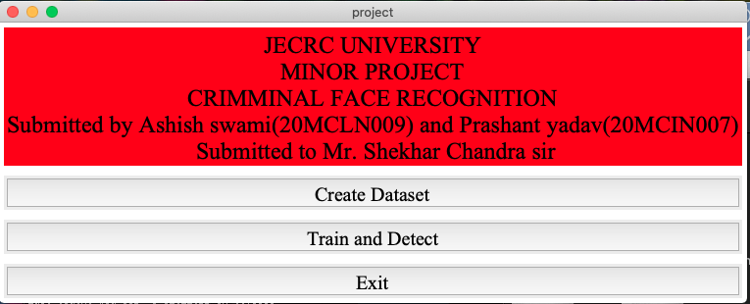

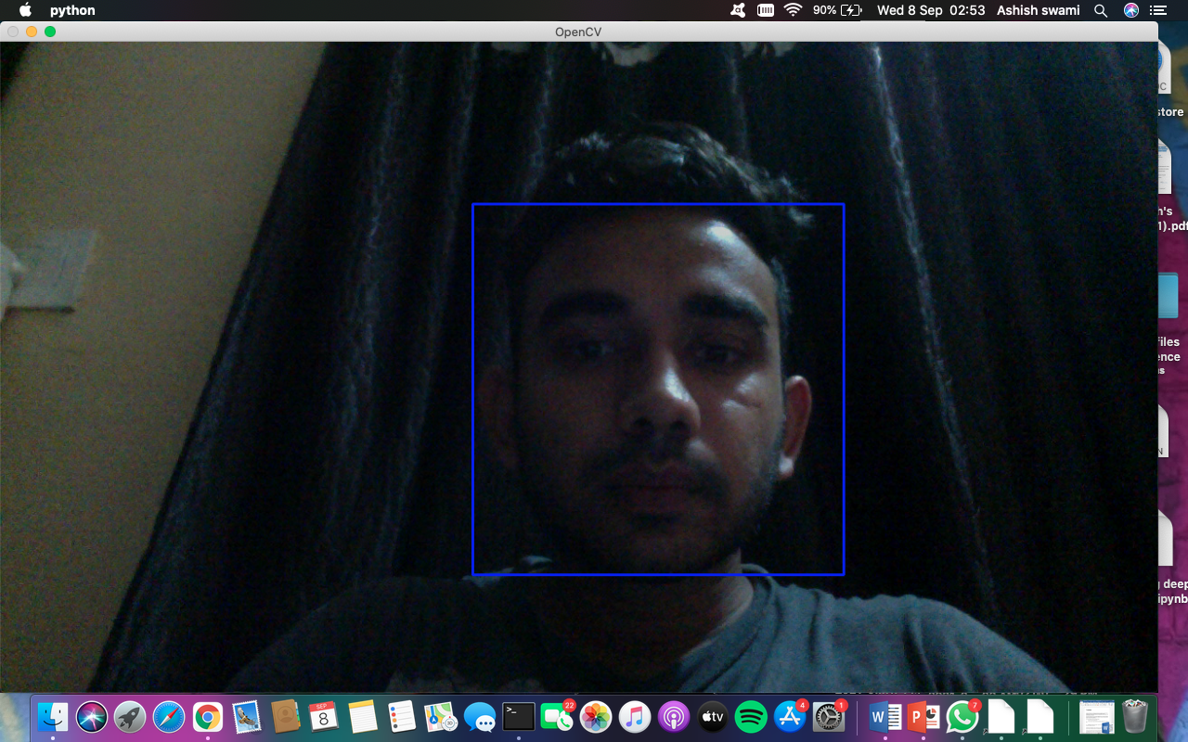

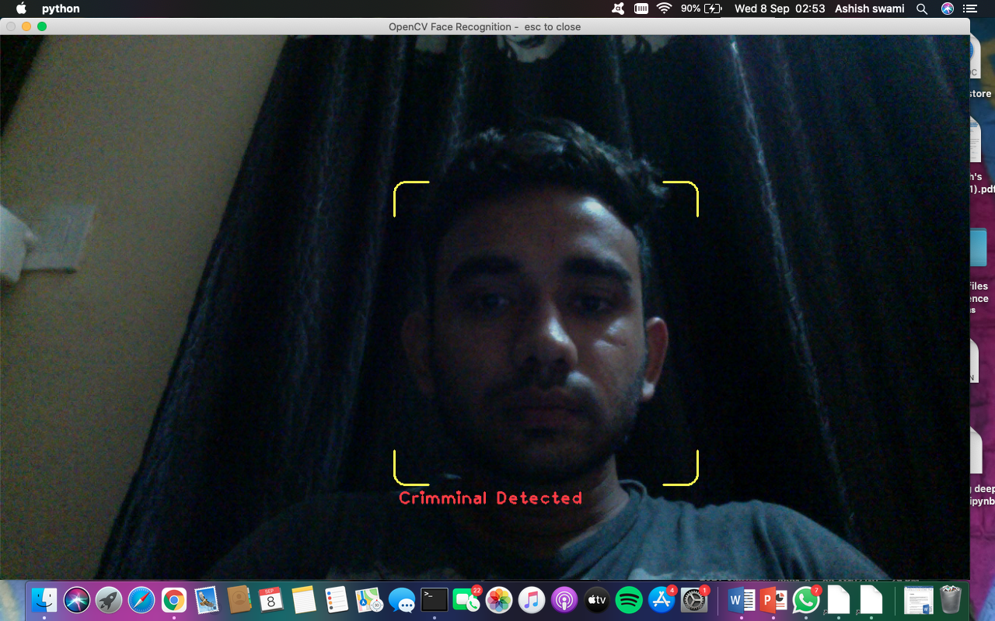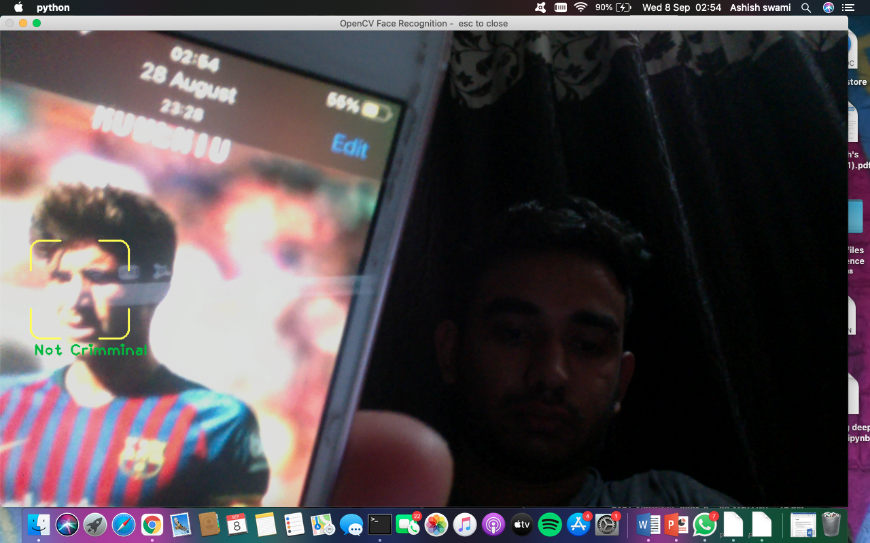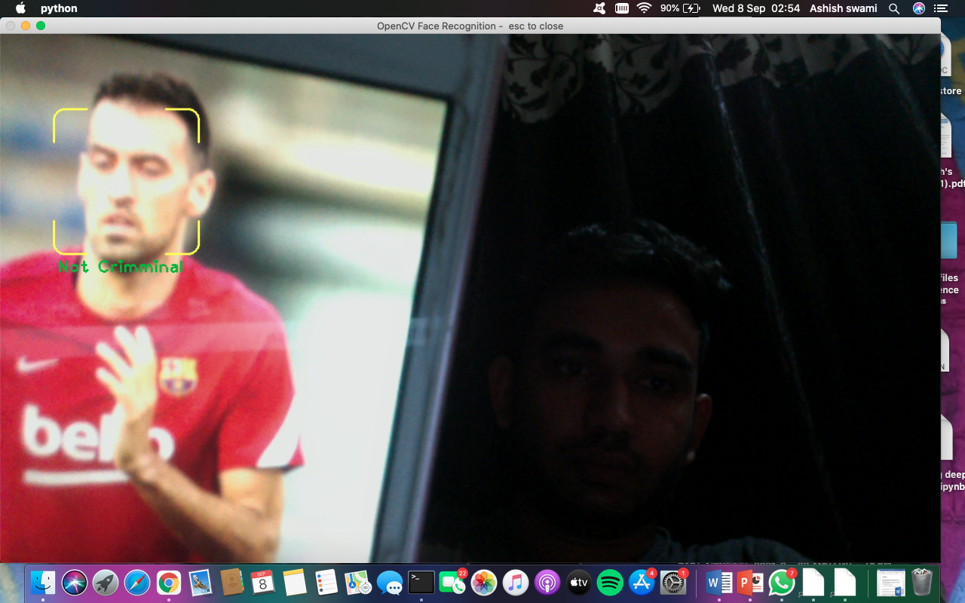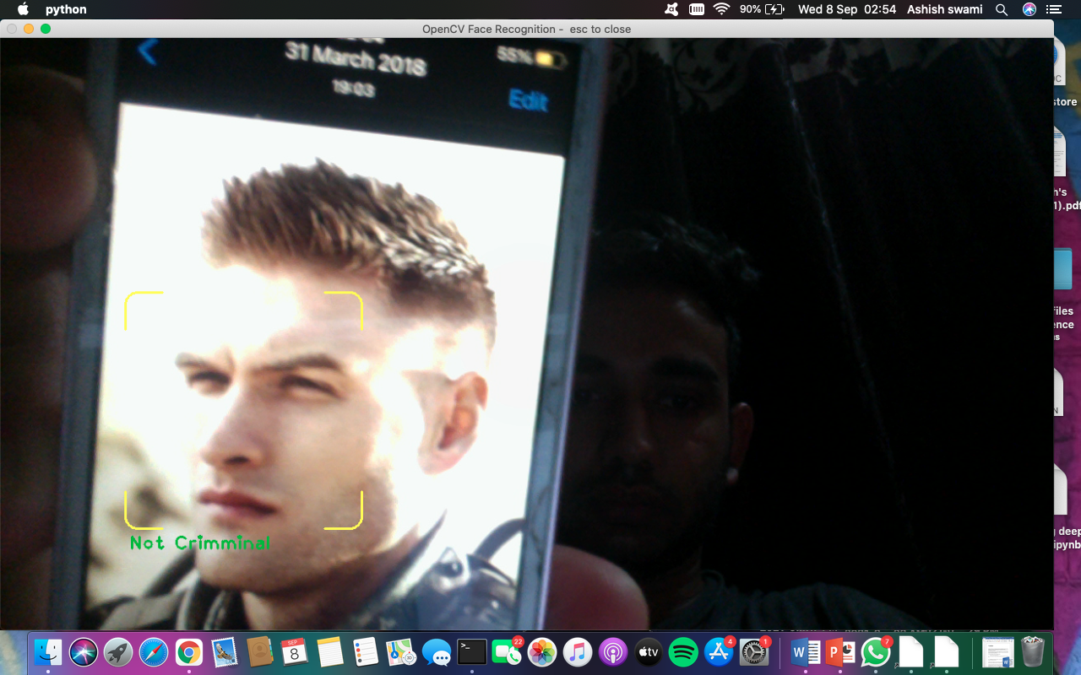

**16.Conclusion**

Criminal face recognition is a generalize project which can be implement in any major projects . The objective of the project is to computerize and create user friendly environment..

This system will provide a better way of Detecting the criminal. The system will maintain the accuracy as it analyses from the database . The security of the system will also increase. Only the user can modulate data.

The Tkinter used together provide a user-friendly interface:

1. To click on database creation.
2. To provide various buttons according to project.
3. Administrator User has all of the rights i.e. add, edit, delete and view all the sensitive information maintaining in this project.

This project has been designed to work on a large scale. So, according to our analysis the future scope of the project is bright and would have an everlasting effect on the current system.

The future scope of this project is that it would be provided with the functionalities of Bugs Report and submitting facility in case there is any abnormal failure in the project. Similarly like in Window XP if the it crashes the bugs reporting screen appears and is logged. We would like to implement our project in the same way.

Next, we would like to make the project work even faster in case the varies other functions like stock rates.

Currently, our software is fully compatible with all those systems which can run html pages correctly and efficiently. So, there is no compatibility issue in our webpage in future.

Hard disk space required is as that of ram usage for webpage which is not much. So, even 4 GB hard disk having windows XP can make the software in good working condition.

**17. BIBLIOGRAPHY**

**Bibliography**

1.opencv –www.w3school.com

2.Tkinter – www.w3school.com

3. [www.towardsdatasciece.com](http://www.towardsdatasciece.com)